**1. Upload All Static Content of Your Website to Azure**

* Use Azure Blob Storage to store all static assets (like images, CSS, and JavaScript files).

**Steps:**

# Create Storage Account for Team 1

**az storage account create --name shahidteam1 --resource-group rg-1 --location "South Central US" --sku Standard_LRS --tags**

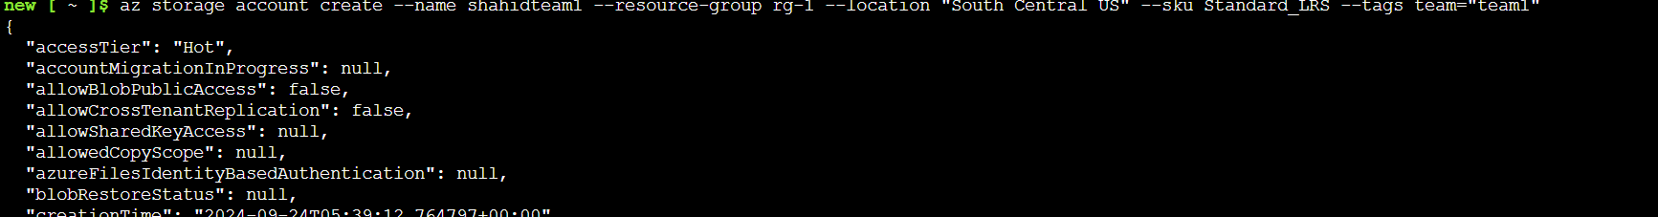

**Step 2: Create a Blob Container**

**az storage container create --name mycontainer --account-name shahidteam1**

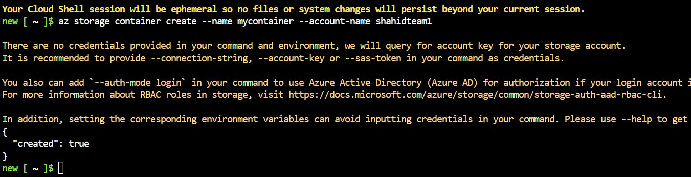

**Step 3: Upload Files**

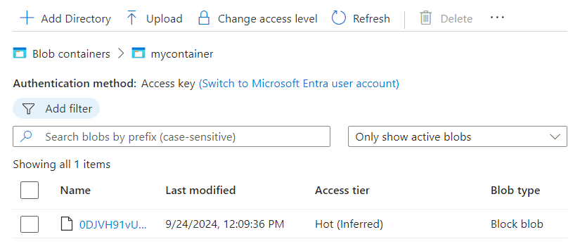

**2. Create Storage Accounts for Critical and Non-Critical Data**

* Set up two storage accounts: one for critical data and another for non-critical data. Enable both global and local replication.

**Steps:**

# Create a storage account for critical data

**az storage account create --name mycriticaldata --resource-group rg-1 --location eastus --sku Standard_GRS**

# Create a storage account for non-critical data

**az storage account create --name mynoncriticaldata --resource-group rg-1 --location eastus --sku Standard_LRS**

**3. Use Shared Access Keys to Link the Web App with the Storage Account**

* Use the shared access keys to connect your web application to the Azure storage accounts.

**Steps:**

# Get the connection string for the storage account

**az storage account show-connection-string --name shahidteam1 --resource-group rg-1**

*Use the connection string in your web application code to access the storage account.*

**4. Create a CDN Endpoint and Configure It to Serve the Static Files**

* Set up Azure CDN to cache and serve the static files.

**Steps:**

# Create a CDN profile

**az cdn profile create --name mycdnprofile --resource-group rg-1 --sku Standard_Verizon --location eastus**

# Create a CDN endpoint

**az cdn endpoint create --name mycdnendpoint --profile-name mycdnprofile --resource-group rg-1 --location eastus --origin shahidteam1.blob.core.windows.net**

**5. Create an Azure File Share and Upload All Tools and Files**

* Create an Azure File Share for sharing tools and files among colleagues.

**Steps:**

# Create a storage account for file sharing

**az storage account create --name shahidteam2 --resource-group rg-1 --location "South Central US" --sku Standard_LRS**

# Create a file share

**az storage share create --name shahidteam1fileshare --account-name shahidteam2**

# Upload files to the file share



**Connect a Linux and Windows VM Box to the File Share**

**Mount the File Share on Linux**

**Step 1: Install cifs-utils**

You need to have cifs-utils installed. You can install it using the following command:

For Ubuntu:

**sudo apt update**

**sudo apt install cifs-utils**

**Step 2: Create a Mount Point**

Create a directory to mount the file share:

**sudo mkdir /mnt/shahidteam2**

**Step 3: Mount the File Share**

Use the following command to mount the file share:

**sudo mount -t cifs //shahidteam2.file.core.windows.net/shahidteam1fileshare /mnt/shahidteam2 -o vers=3.0,username=shahidteam2,password=<password>',dir_mode=0777,file_mode=0777,sec=ntlmssp**

**For Windows VM:**

1. Open **File Explorer**.
2. Click on **This PC**.
3. Click on the **Computer** tab and then select **Map network drive**.

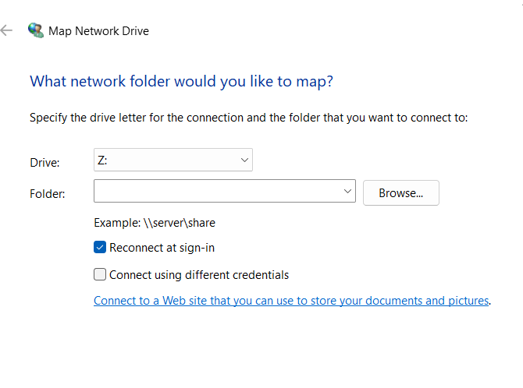

1. Choose a drive letter (e.g., Z:).
2. In the Folder box, enter the following:

\\**shahidteam2.file.core.windows.net\shahidteam1fileshare**

1. Click on **Connect using different credentials**.

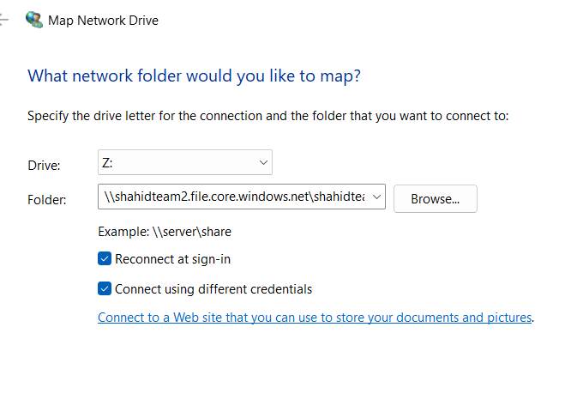

1. For the username, enter:

**Azure\shahidteam2**

1. For the password, use a storage account key, which you can get by running:

**az storage account keys list --account-name shahidteam2 --query "[0].value" --output tsv**

1. Click **OK** to mount the drive.